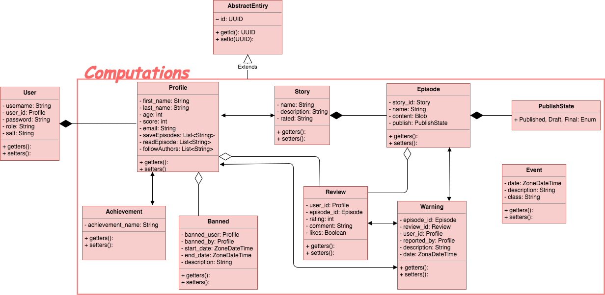

Rest Services

UserService:

* createUser(User): boolean
* changePassword(User, String)
* changeRole(User, String): boolean

ProfileService:

* createProfile(Profile): boolean
* updateProfile(Profile): boolean
* editProfileAuthor(List<String>): boolean
* getUserAuthors(String): List<String>
* updateProfileAchievement(String, Achievement): boolean
* saveReadStory(String): boolean
* getReadStories(): List<String>
* addSaveStory(String): boolean
* deleteSaveStory(String): boolean
* getSaveStories(): List<String>
* getProfile(String): Profile

LogService:

* saveEvent(Event): boolean

RestService:

* Service will be updated

WarningService:

* addWarning(Warning)
* getWarnings(): List<String>
* getWarning(String): Warning

StoryService:

* createStory(Story)
* deleteStory(String)
* updateStory(Story) -> only published stories
* addEpisode(Episode)
* deleteEpisode(String)
* updateEpisode(Episode)-> only published stories
* getStory(story_id): Story
* getEpisode(episode_id): Episode
* getEpisodes(String): List<Episode>
* getStoryCategories(String): List<Category>
* getTopCategoryStories(Category): List<Episode>
* getTopStories(): List<Episode>

ReviewService:

* addReview(Review): boolean
* deleteReview(User, String): boolean
* updateReview(User, Review): boolean
* getReviews(Episode): List<Review>
* getReview(String): Review
* getReviews(Profile): List<Review>

CategoryService:

* createCategory(Category)
* deleteCategory(String)
* updateCategory(Category)
* getCategories(): List<Category>
* getCategory(String): Category

AchievementService:

* createAchievement(Achievement): boolean
* updateAchievement(): boolean
* deleteAchievement(String): boolean
* getAchievements(): List<Achievement>
* getAchievement(String): Achievement

Service Layer

EmailService

* sendEmailAlert(): Event

BatchService:

* computeFeatureAuthors(): Event
* computeFeatureStories(): Event
* getRecommendedStories(): Event
* computeUserRecommendations(): Event
* computeWarnings(): Event